# Homework 9 Two-dimensional lists

1. State the address of the values (a), (b), … (f) (ignore the header row)­:

**games**

|  |  |  |  |
| --- | --- | --- | --- |
| Game | Genre | 2016 Sales (millions) | Platform |
| Pokemon Sun/Moon | Role Playing | 12.0 | 3DS |
| FIFA 17 | (a) | 10.0 | (b) |
| Uncharted 4: A Thief’s End | Shooter | (c) | PS4 |
| (d) | Shooter | 6.3 | PS4 |
| Battlefield 1 | (e) | 6.25 | PS4 |
| Grand Theft Auto V | Action | 4.3 | (f) |

*Source: http://www.vgchartz.com/yearly/2016/Global/*  
  
(a) games[1][1]

(b)

(c)

(d)

(e)

(f)

[5 marks]

1. Choose which 2D list would be created by running the following code:

scores = [ [3,5] , [6,12] , [9,15] ] [1 mark]

(a)

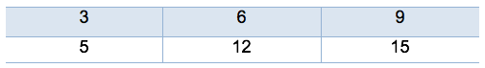­­

(b)

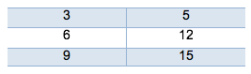

1. Look back at Question 1. State the result of these lines of code:
2. print(len(games)) [1 mark]
3. print(len(games[0])) [1 mark]
4. State the result and describe the purpose of the following code:

for count in range(len(games[2])):  
 print(games[2][count] [2 marks]

1. Describe the purpose of the following code:

total = 0  
for count in range(len(games)):  
 total = total + games[count][2]  
print(total) [2 marks]

1. State the result and describe the purpose of the following code:

games = sorted(games, key=lambda data:data[0], reverse = True)  
print(games)[2 marks]

[Total 14 marks]